# THE TABLEAU HR SCORECARD SUCCESS IN TALENT MANAGEMENT

# INTRODUCTION:

* 1. **Overview:**

HR scorecards emerge out of the “balanced scorecard” theory founded by management consultant Arthur M. Schneiderman. Schneiderman originated the balanced scorecard out of a work assignment to connect the dots between his employer’s quality improvement and strategic goals. The end goal for an HR scorecard is to establish a linkage between HR and organizational goals in support of strengthening the employer-employee relationship, creating a productive work environment and improving the bottom line. For example, one of the categories that HR scorecards measure is employee turnover. Through measuring turnover, an HR scorecard evaluates how turnover impacts the company’s profits, how much it costs to replace employees, the effect turnover has on remaining employees’ morale and, thus, the organization’s strategic goal to foster a productive work environment.

The Tableau HR Scorecard is a framework designed to measure and evaluate the success of talent management strategies within an organization. It provides a way for HR professionals and business leaders to track and analyze key performance indicators (KPIs) related to workforce planning, recruitment, retention, and development.

# Purpose:

* **FINANCIAL PERSPECTIVE**: This perspective focuses on the financial impact of HR initiatives, such as the cost of recruitment, training and development, compensation and benefits, and turnover.
* **CUSTOMER PERSPECTIVE**: This perspective measures the satisfaction of internal and external customers of HR services, including employees, managers, and job candidates. It includes KPIs such as employee engagement, manager satisfaction with HR support, and candidate experience.
* **INTERNAL PROCESS PERSPECTIVE**: This perspective assesses the effectiveness and efficiency of HR processes, such as recruiting, onboarding, performance management, and employee development. It includes KPIs such as time to fill vacancies, time to productivity for new hires, and training hours per employee.
* **LEARNING AND GROWTH PERSPECTIVE**: This perspective evaluates the organization's investment in employee development and its ability to innovate and adapt to changing business needs. It includes KPIs such as employee skills and competencies, employee retention, and the percentage of employees who receive regular training and development.We can achieve more customers and improve income using these ideas.

# Problem Definition & Design Thinking:

# 2.1 EMPATHY MAP:

# 

# Indeation & Brainstroming Map:

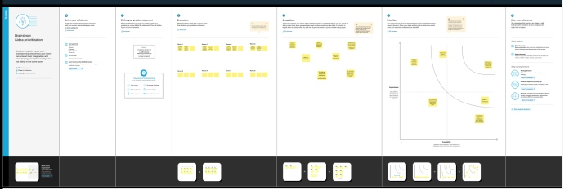

**RESULT:**

Sheet 1

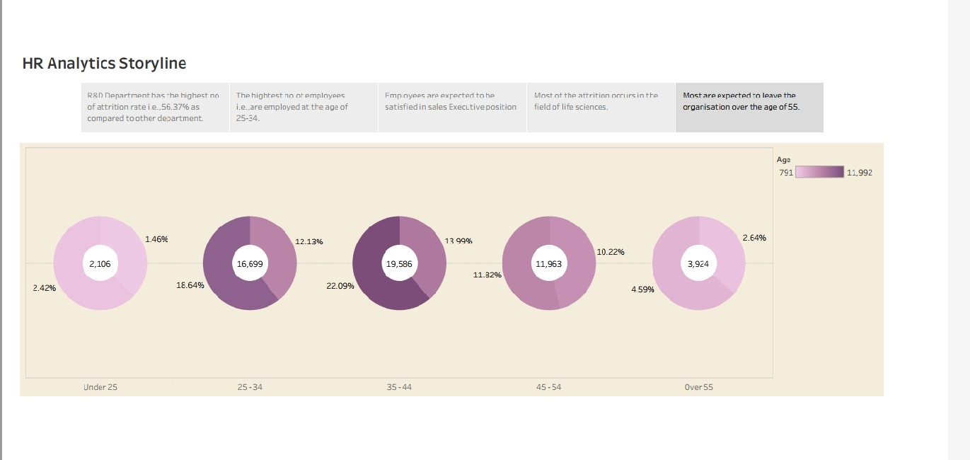

Sheet 2

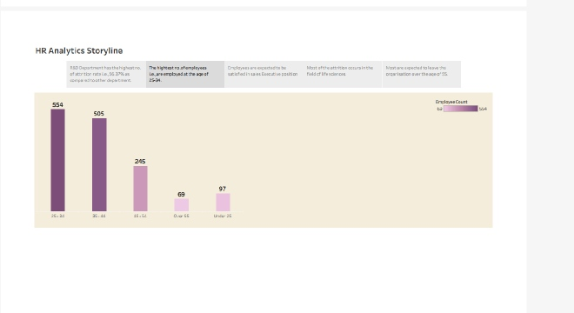

Sheet 3

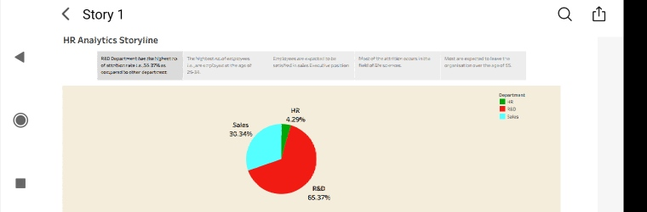

Sheet 4

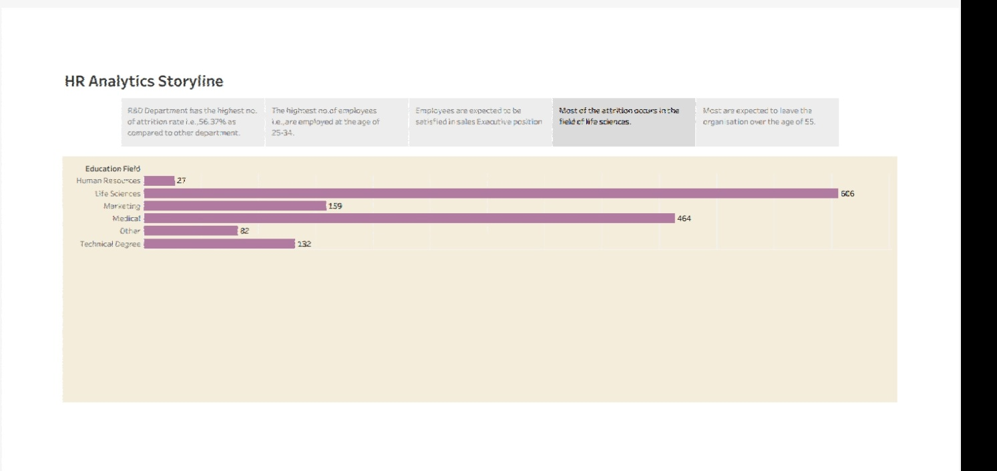

Sheet 5

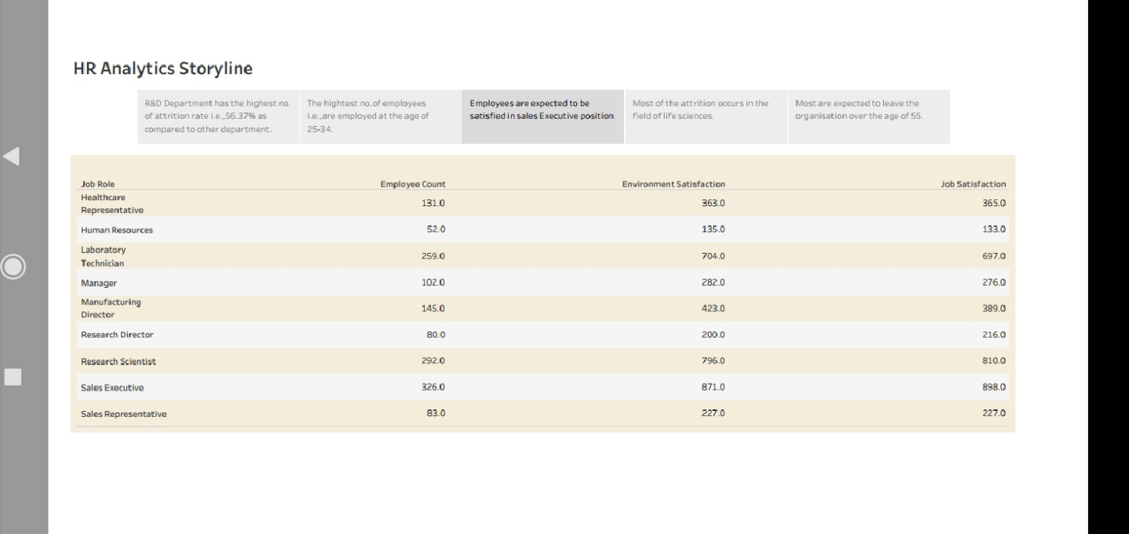

Dashboard 1

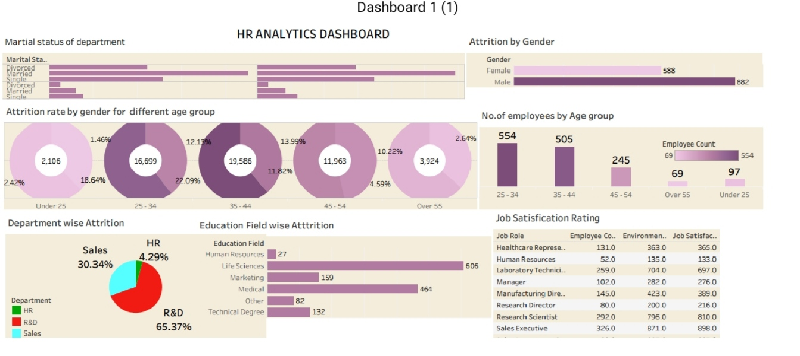

Story

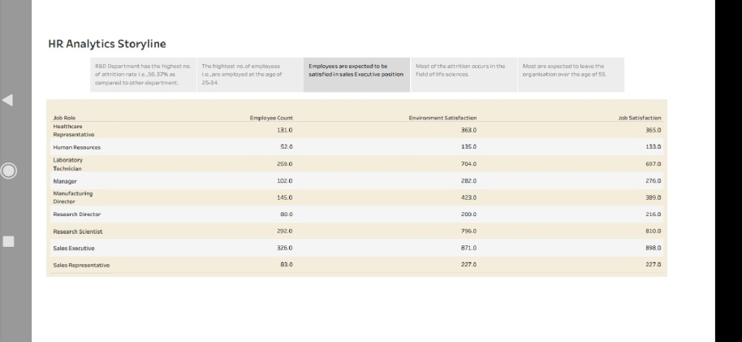 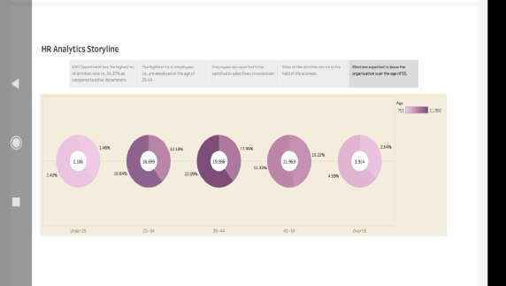 

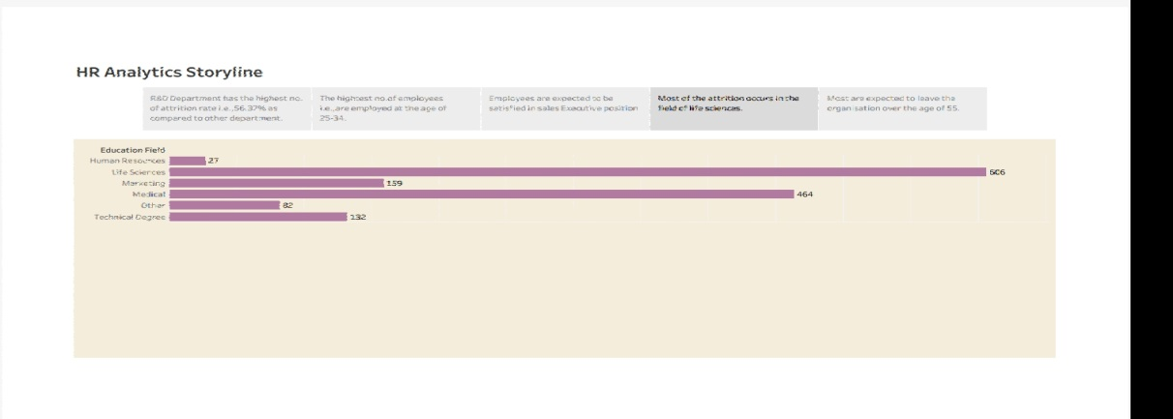

In this we analysis the trips by

* + 1. Bar graph showing Purpose of Attrition of female and male
    2. Bar graph showing the age group.
    3. Pie chart showing the total number of employees and job heads.
    4. Highlight Table shows the education qualification in percentage.
    5. Bar graph showing Month with salary.

# Advantage and Disadvantages:

* + - Brings structure to business strategy.
    - Makes communication easier.
    - Facilitates better alignment.
    - Connects the individual worker to organizational goals.
    - It must be tailored to the organization.
    - It needs buy-in from leadership to be successful.
    - It can get complicated.

# APPLICATIONS:

Traditionally, HR has focused a lot on creating efficiencies. When it comes to creating an HR scorecard, some efficiencies have to be thrown out of the window.The simple reason here is that to get, for example, a higher quality of hire, your cost to hire someone might go up. In our example, the quality of hire is a strategic HR measurement. Investing money into increasing the quality of hire is well worth it. This justifies investments in assessments, employer branding projects, and other HR initiatives that boost the main HR deliverables.

## ACTION:

## The term “HR scorecard” can be a misnomer because it suggests that measurement is the only expectation. Another disadvantage to HR scorecards is that their usefulness can be limited by both HR staff and the company’s leadership. Ideally, an HR scorecard doesn’t just contain metrics related to HR functionality and the linkages between HR, the workforce and the organization’s business goals. The extended purpose of an HR scorecard is to develop action plans for the HR department and the company’s leadership team. For example, instead of simply measuring the impact of turnover on the organization’s workforce goals, use HR scorecard metrics in drafting an action plan for turnover reduction.

# CONCLUSION:

# The HR scorecard is meant to measure leading HR indicators of business performance. Leading indicators are measurements that predict future business growth. These are called HR deliverables. They are also known as [HR metrics](https://www.aihr.com/blog/14-hr-metrics-examples/), and more specifically [HR KPIs](https://www.aihr.com/blog/human-resources-key-performance-indicators-hr-kpis/), as they are metrics that are linked to the business strategy.

# FUTURE SCOPE:

It provides a way for HR professionals and business leaders to track and analyze key performance indicators (KPIs) related to workforce planning, recruitment, retention, and development.